Let Your Imagination Fly…………….

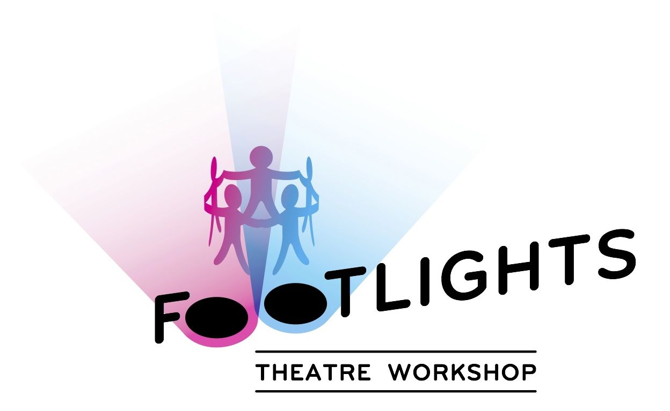

A Frozen Summer

If your child is Frozen mad then come & join me for an hour filled with Frozen drama games & lots of fun!

Let me take them on a fabulous Frozen adventure created by the children and guided by me, all to music.

Price £10 per child

Suitable for 3-6 Years



**Contact Nikki on 07956912311**

**or** [footlightstheatreworkshop@gmail.com](mailto:footlightstheatreworkshop@gmail.com)

At Immanuel Church Hall, 452 Streatham High Rd, SW16

(Next to Sainsbury’s S/ham Common)

**Wednesday 29th July 11-12**



Wor