Let Your Imagination Fly…………….

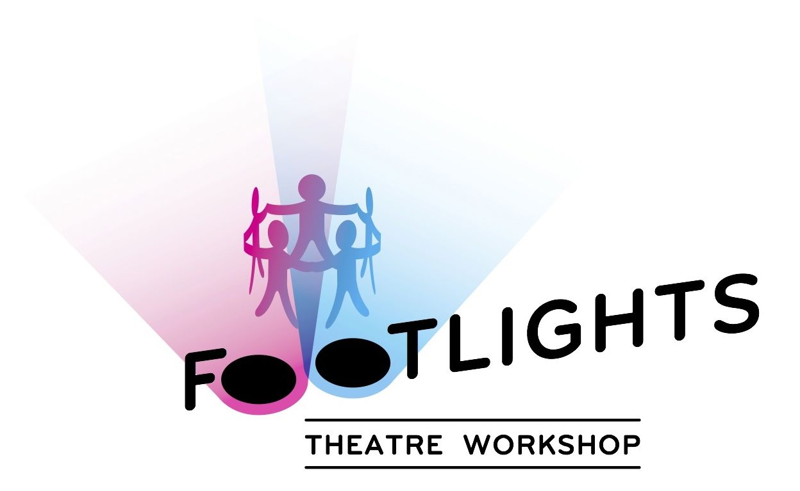

Summer Holiday Fun

‘A Play In A Day’

Come & join us for a fun filled day creating a play to perform - all in ONE DAY!

Workshops will take place on **Tues 28th July & Tues 4th** **August** 9.30am – 3.30pm.

At Vinters Studios, 1b Sunnyhill Rd, SW162UG

Price £35 per child

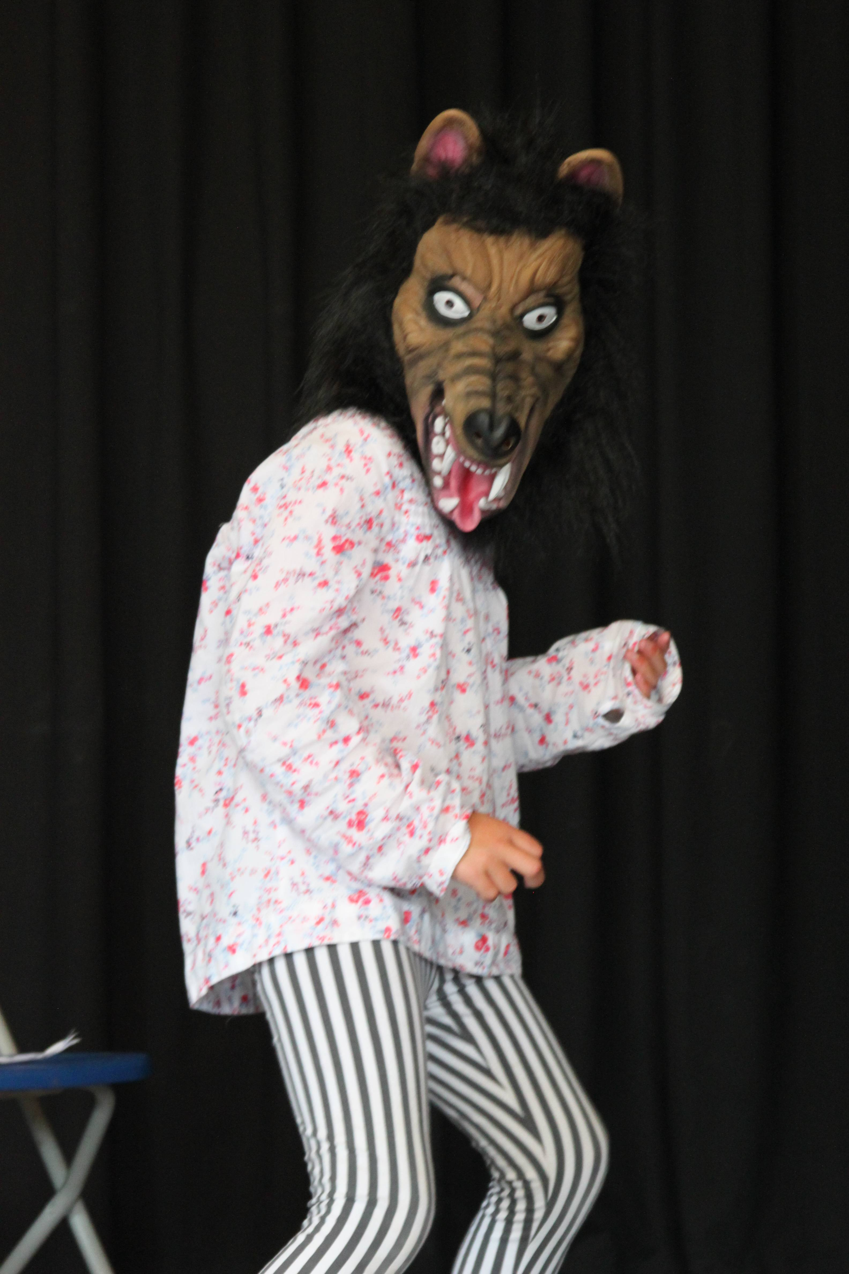

**Contact Nikki on 07956912311**

**or** [footlightstheatreworkshop@gmail.com](mailto:footlightstheatreworkshop@gmail.com)

**to reserve your place.**

*Places are limited and must be pre-paid in order to cast the play. Age 6+

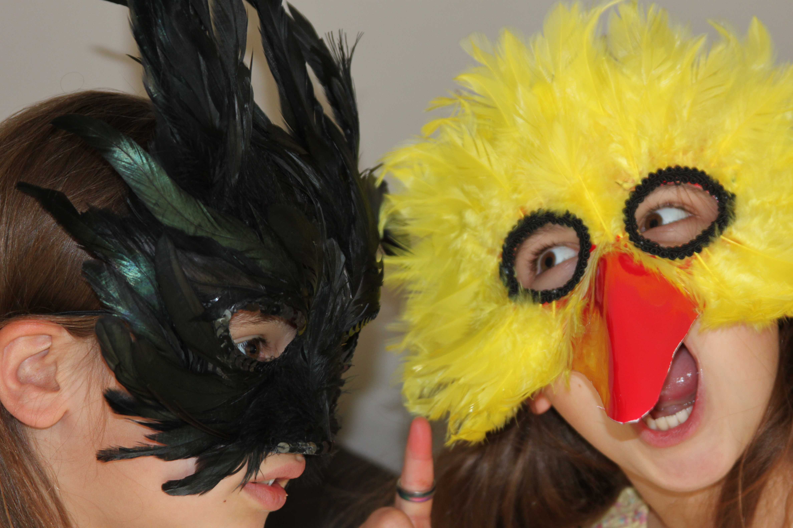

Wor